07/05/2025

**HOSPITAL MANAGEMENT SYSTEM**

**AKIRA HOSPITAL MANAGEMENT**

**List of similar products :**

|  |  |  |
| --- | --- | --- |
| Product name | Features | Url |
| HMS -HOSPITAL MANAGEMENT SYSTEM | Doctor Side: Patient management, appointment scheduling, diagnosis & prescription updates.  Patient Side: Appointment booking, medical history access, secure diagnosis & prescription viewing.  System Features: Prevents clashes, enhances privacy, and ensures smooth hospital operations. | https://github.com/hrishikeshathalye/Hospital-Management-System-DBMS |

RollNo.: 927623BAD018

Name : DEVADHARSHINI G

Official ID : [927623bad018@mkce.ac.in](mailto:927623bad018@mkce.ac.in)

Personal ID: [devadharshinig95@gmail.com](mailto:devadharshinig95@gmail.com)

Phone Number: 8903390991

**Contribution :** Table normalization , Form design, Connecting to the DB, Reports , Schema design

Sites.google.com

Portfolio

Github

Leetcode

Github url: [dharshu05g (Devadharshini Gunasekaran)](https://github.com/dharshu05g)

Tables :

* Doctors - master table
* Patients - transaction table
* Appointments - transaction table

Doctor table

Doctor_id - primary key

Doctor_name

Specialization

Patient table

Patient_id - primary key

Patient_name

Doctor_id - foreign key

Appointment table

Appointment_id - primary key

Doctor_id - foreign key

Patient_id - foreign key

Billing table

Invoice_id - primary key

Patient_id - foreign key

Doctor_id - foreign key

Total_value

Create table doctor(

Doctor_id varchar(225) primary key,

Doctor_name varchar(225),

Specialization varchar(255)

);

Select * from doctor

Insert into table

CREATE VIEW cardiologists AS

SELECT Doctor_id, Doctor_name

FROM doctor

WHERE Specialization = 'Cardiology';

**Keywords**

Relation - doctor

Attributes - doctor_id

Domain - doctor_id - start with AKdoc

Tuples - value

**Database normalization**

* 1NF
* 2NF
* 3NF
* 4NF
* 5NF

Doctor table:

1NF

* My table is a 1NF because it has a primary key named doctor_id .

2NF

* My table is a 2NF because it has a primary key - doctor_id , all other columns are dependent on the primary key .

3NF

* Should be in 2NF
* no transitive partial dependency

Example : student_id, student_name , job_id,job_name, state_id , state_name

|927623bad018 | Devadharshini | J_0118 | Software Engineer| 601| Karur|

1NF - student_id, student_name

2NF

Student roll

Student_id, job_id

Student_info table

Student_id

Student_name

State_id

State_name

Job table

job_id

Job_name

3NF

Student roll table

Student_id

job_id

Student info table

Student_id

Student_name

State_id

Job info table

Job_id

Job_name

State_id

State_name

Front end - HTML,CSS, reactjs, tailwin css, flask , android , flutter

Back end - MySQL, Oracle, mangoDB, JSON, SQLlite, fire base

Editor - VScode

Framework - XAMPP v3.3.0 ,Nodejs

Language - Python

ER diagram

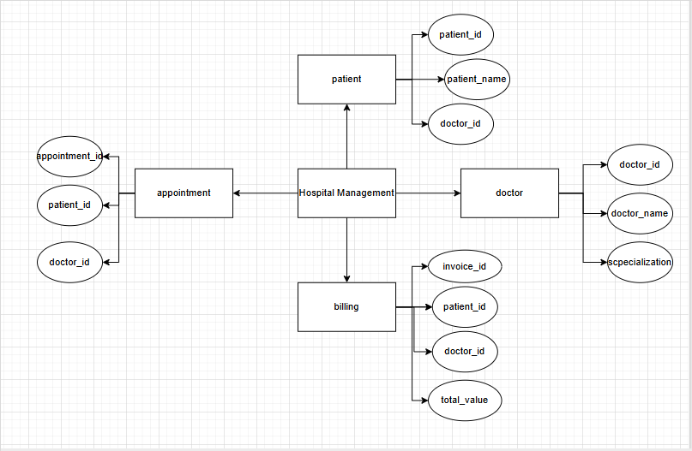

XML

Example:

Doctor - parent tag

Doctor_id, doctor_name, spealization - child tags

<xml>

<doctorinfo>

<doctor>

<doctor_id> AKdco01 </doctor_id>

<doctor_name> Milly </doctor_name>

<specialization> Cardiologist </specialization>

</doctor>

<doctor>

<doctor_id> AKdco02 </doctor_id>

<doctor_name> Lucy </doctor_name>

<specialization> Dermatologist </specialization>

</doctor>

<doctor>

<doctor_id> AKdco03 </doctor_id>

<doctor_name> Kevin </doctor_name>

<specialization> Cardiologist </specialization>

</doctor>

</doctorinfo>

</xml>

**DTD**

<!DOCTYPE doctorinfo[

<!ELEMENT doctorinfo (doctor*)>

<!ELEMENT doctor(doctor_id,doctor_name,specialization)>

<!ELEMENT doctor_id (#PCDATA)>

<!ELEMENT doctor_name (#PCDATA)>

<!ELEMENT specialization (#PCDATA)>

]>

**DTD with no elements**

<login timeout = “100” > </login>

<ELEMENT login empty>

<!ATTLIST login timeout CDATA “1”>

**JOIN**

Inner join

Select *

from doctor

Inner join patient on doctor.doctor_id = patient.doctor_id ;

**Module details:**

|  |  |  |
| --- | --- | --- |
| **Module name** | **submodule details** | **description** |
| Doctor Management | Add doctor | Register doctor with specialization and qualification. |
| View doctor | List of doctors with availability status. |
| Doctor schedule | Manage consultation hour and leave schedule. |

**Form details :**

|  |  |  |  |  |
| --- | --- | --- | --- | --- |
| **Module name / submodule name** | **Form name - type** | **Form description** | **Table name - type** | **Table description** |
| Order / Book order | Book order form - Transaction | I can see the food items list and book for the order. | Order table - transaction | Orders are listed in here. |
| Appointment / Schedule appointment | Schedule appointment- Transaction | Here I can schedule the appointments for doctors /patients. | Appointment table- Transaction | Book appointments with doctor/ patients. |